**Examining the Information Content of Voltage-Dependent, Two-Dimensional Conductance Histograms**

**2013-2014**

**Gaibo Zhang**

**Oak Ridge High School, Oak Ridge, TN 37830**

**Mentor: Dr. Matthew G. Reuter**

**Computer Science & Mathematics Division and Center for Nanophase Materials Sciences, Oak Ridge National Laboratory, Oak Ridge, Tennessee 37831, United States**

1. **Introduction**

In nanometer-scale systems in which quantum mechanical effects are crucial, the study of the conductance of a single molecule is a topic that has recently undergone significant advances. This area of research has garnered excitement due to potential applications in areas such as molecular electronics, photovoltaic technologies, and thermo-electrics. It is popularly hoped that a better understanding into the realm of molecular conductance properties will ultimately lead to the replacement of electronic components with single molecules, allowing for dramatic size reduction. An application could thus be in creating smaller circuit components for the placement of more transistors in processor chips, resulting eventually in increased processing power for both industrial and personal uses. Moore’s law expects the miniaturization of circuits to the atomic level in ten or twenty years, and molecular circuitry is the next logical step for present-day technological innovation [1]. However, current challenges exist in finding the most efficient way to measure the molecular conductance experimentally, and also in the analysis of the physical factors contributing to the property [2].

In contrast with conventional electronics, molecular systems do not have precisely measurable physical properties. The workings of quantum electron transport as well as small changes in particular parameters contribute to variation in tests. The molecule can be thought of as a collection of channels where there are a finite number of channels within the molecular system that can be used for transmission of electron charges [2] [3]. These channels have varying states of conductance ranging from zero (closed) to one (open). A conductance of zero means no electron transport, while a value of one means guaranteed transport. The quantum of conductance, *G0*, is defined

$G_{0}=\frac{2e^{2}}{h}$ (1)

where *e* is the electron charge and *h* is Planck’s constant. The quantum of conductance is the constant associated with a channel that has a conductance of one. That is, the “one” indicates a channel conductance of one quantum of conductance. The conductance of the single molecule is then the sum of all the constituent conductances of the channels [2]. Note that because of the variation in conductance of a single channel, total conductance of the molecule is not necessarily an integer multiple of the quantum.

The variability of the limited number of channels due to physical junction contact differences then creates significant uncertainty in stating an official value for conductance [4]. The electric properties of a single molecule have also been repeatedly shown to be highly dependent on electrode contact geometry [5]. As there is currently no way to consistently replicate the molecular arrangement for each measurement, methods such as the mechanically controllable break junction (MCBJ) and the scanning tunneling microscope (STM) break junction have been employed in order to make large amounts of measurements for study. The general break junction method essentially involves pulling a contact, which can be the tip of a scanning microscope among other things, away from the substrate and monitoring current.

When applying the break junction method, eventually only a single molecule will cling to the tip, and further retraction will result in the circuit breaking. The measured current all the way down to the single molecule can thus theoretically be determined, yielding the conductance value.

**Conductance Histograms**

Large amounts of data are necessary to account for the variations in contact geometry, so conductance histograms, as shown in Figure 1, are a common way for experimental studies to characterize the conductance of the system. Experimental techniques, such as STM or MCBJ, are performed thousands of times to generate large amounts of conductance data, and the properties are then be determined statistically. After compiling the data into the histogram, there is much debate on how the results should be interpreted. In general, the peak is considered to be the “expected” conductance. Extensive work has been done in modeling the line shape of the histogram using distributions such as double beta, log-normal, normal, and Lorentzian [6]. The peak width depends on chemistry and structure of the molecule, especially on electrode contact geometry.

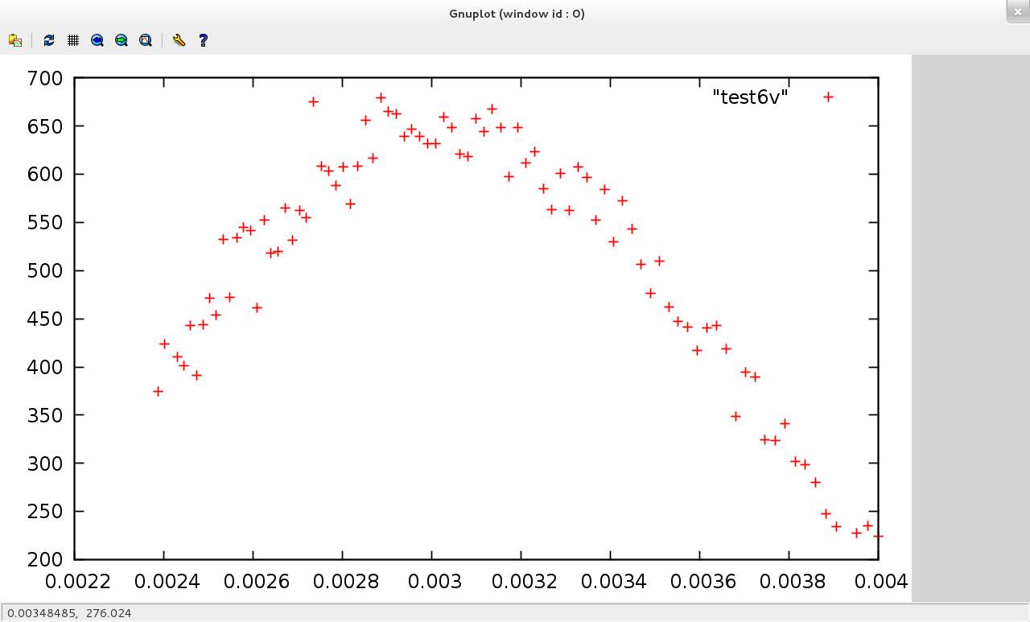

Conductance (in units of *G0*)

Counts (Number of Occurrences)

**Figure 1.** A typical one-dimensional conductance histogram, with conductance on the x-axis and number of occurrences on the y-axis. The peak here is around 0.003.

Developments in 2011 by S. Guo et al. involved a new experimental method that gave a new dimension to the conductance analysis with measurements of current-voltage, conductance-voltage, and transition voltage histograms. In the new technique, the STM break junction method was used, but when a step (sudden drop) in current was detected as the tip was pulled farther away from the substrate, the tip was held still and voltages were swept for one voltage cycle, meaning a range of voltages was applied and the variation in current and conductance data recorded [5]. This allowed for the creation of meaningful current-voltage (I-V) and subsequently-constructed conductance-voltage (G-V) graphs for each step, giving a two-dimensional view on the information of the step. Until their work, conductance tests had been limited to around 100 mV of potential across the minuscule and fragile molecular junctions, and analysis of the molecular conductance assumed that potential to be negligible. The group’s improved technique managed to run a cycle of voltages ranging from -2 V to 2 V during data collection, effectively introducing the necessity of consideration of voltage in molecular conductance. The work verified that variation in molecular conductance is primarily due to contact resistance rather than changes in energy level alignment, and the addition of the voltage, or *bias*, factor still confirmed conductance for alkanedithiols and biphenyldithiol at low values. However, at high biases, the results were notably less explainable and the group left them as an open question.

The field of study is ready for in-depth study on the effects of a high applied bias to the molecular system. This project attempts to explain the two-dimensional conductance histograms of S. Guo et al. using mathematical models. In contrast to traditional conductance histograms which use an axis of conductance values versus an axis of number of times observed, two-dimensional G-V histograms relate voltage to conductance while preserving the relative probability of the conductances using contour shading (a one-dimensional dimensional conductance histogram will result from a cross-section at any bias value), as shown in Figure 2. In this research, an attempt is made to relate the additional physical parameter of bias voltage to its effects on changes in conductance data, along with the other meaningful physical information previously studied in the analytical model developed by P. D. Williams and M. G. Reuter such as the energy of the electron, the channel energy, the channel-electrode coupling, and the Fermi level [2].

**(b)**

**(a)**



**Figure 2.** The format of a typical two-dimensional G-V histogram. The lines on (a) indicate the “cross-sections” depicted in the one-dimensional conductance histograms in (b) for clarity. Your vertical bars misaligned.

1. **Methods**

**Voltage-Dependent Electron Transport**

Used in this project as a basis for mathematical calculation is the Landauer-Büttiker-Imry coherent scattering theory for electron transport. In this project, the key quantity is the transmission function,

$T\left(E\right)=\frac{Γ^{2}}{{\left(E-ε\right)}^{2}+Γ^{2}}$ (2)

where *E* is the energy of the electron, *ε* is the channel energy, *Γ* is the channel-electrode coupling (assuming channel couples symmetrically to both electrodes), and *T* is the transmission of the electron. The current is then given by

$I\left(V\right)=\frac{2e}{h}\int_{-∞}^{∞}{dET\left(E;V\right)}\left[f_{L}\left(E;V\right)-f_{R}\left(E;V\right)\right]$ (3)

where *I* is the current, *V* is the applied bias, and *fL* and *fR* are the Fermi functions of the left and right electrodes respectively. *T(E)*, in principal, depends on *V* which makes it possible to relate the transmission and thus conductance to the bias in this model.

For simplicity, this model is assumed to be operating at zero temperature, which eliminates any inelastic effects, allowing for use of the Landauer-Büttiker-Imry formalism. In this limited-temperature case,

$f_{L}\left(E;V\right)→Θ\left(-E+E_{F}+ηeV\right)$ (4)

$f_{R}\left(E;V\right)→Θ\left(-E+E_{F}+\left(η-1\right)eV\right)$ (5)

where *Θ* is the Heaviside step function, *EF* is the Fermi energy of the system, and 0 ≤ *η* ≤ 1 controls the relative voltage drop at each of the electrode-channel interfaces. As written, *η* = 0 means all voltage drops at the right electrode and *η* = 1 means all voltage drops at the left. *η* = 0.5 would then indicate symmetric voltage drops, which are special points of interest for generalizations since this project aims to fit a symmetric histogram. Then, from Equation 3,

$$I\left(V\right)=\frac{2e}{h}\int_{-∞}^{∞}{dET\left(E;V\right)}\left[Θ\left(-E+E_{F}+ηeV\right)-Θ\left(-E+E_{F}+\left(η-1\right)eV\right)\right]$$

$=\frac{2e}{h}\int_{E_{F}+\left(η-1\right)eV}^{E_{F}+ηeV}{dET\left(E;V\right)}$ (6)

Finally, looking at the differential conductance, *g(V)*,

$$g\left(V\right)≡\frac{∂}{∂V}I\left(V\right)$$

$$=\frac{2e}{h}\int_{-∞}^{∞}{dE\left\{\frac{∂}{∂V}T\left(E;V\right)\left[Θ\left(-E+E_{F}+ηeV\right)-Θ\left(-E+E_{F}+\left(η-1\right)eV\right)\right]+T\left(E;V\right)\left[ηeδ\left(-E+E_{F}+ηeV\right)+\left(1-η\right)eδ\left(-E+E_{F}+\left(η-1\right)eV\right)\right]\right\}}$$

$$=\frac{2e^{2}}{h}\left[ηT\left(E_{F}+ηeV;V\right)+\left(1-η\right)T\left(E_{F}+\left(η-1\right)eV;V\right)\right]$$

$+\frac{2e}{h}\int_{E_{F}+\left(η-1\right)eV}^{E_{F}+ηeV}{dE\frac{∂}{∂V}T\left(E;V\right)}$ (7)

And in the limit *V* → 0, a common expression is verified:

$g\left(0\right)=\frac{2e^{2}}{h}T\left(E_{F};0\right)$ (8)

which, substituting the quantum of conductance (Equation 1),

$g\left(0\right)=G_{0}T\left(E_{F};0\right)$ (9)

gives the basic equation used for calculating conductance at zero-bias and zero temperature.

**Implementation into Code – Simulating Conductance Data**

Equation 7 provides the differential conductance through a system with a particular *ε*, *Γ*, and *η*. In real experiments, each time the measurement is taken, these values change slightly due to the aforementioned quantum effects, and to simulate this effect, each of these parameters is considered to be a randomized variable. Each simulated experimental measurement is created from a statistical distribution (the normal distribution is used for simplicity): ε comes from a normal distribution with mean *ε0* and standard deviation *δε* and *Γ* comes from a normal distribution with mean *Γ0* and standard deviation *δΓ*. The many experiments are then simulated (in this project, one million runs are simulated each time for a significant distribution) after choosing sets of parameters and calculating conductances by substituting into the derived Equation 7. Appendix 1 shows the equation implemented into the code with voltage-independent functions.

The code written uses standard input to enter a series of values for the mentioned variables into the simulator program. One of the inputs specifies the model, since three different models of varying complexity have been designed for the program. The simplest model, the “i” model, neglects a mathematically complicated integral (the latter part of Equation 7) and generates voltage-independent conductance data, that is, *ε* does not depend on *V*. The “s” model attempts to utilize the integral by making ε linearly dependent on *V*, allowing the integral to be solved. The “d” model is the most complex and involves two conductance “sites”, as if there were two molecules linked together between the electrodes. It essentially involves shifting the two *ε* values for the two sites in opposite directions, both linearly related to *V*, and hence solves the integral in a different way from the “s” model. Our full array of self-explanatory inputs is depicted in Table 1, and Appendix 2 gives more context. After the simulator outputs a list of paired voltage and conductance data, a binner is used to organize the raw data into a format that can be drawn as a two-dimensional histogram. An example of some of the data is shown in Table 2. This data is then stored into a data file named with the parameters for graphing, as shown in Appendix 3. Finally, OriginPro by OriginLab was used to visualize the two-dimensional histograms.

**Table 1.** Definitions of the parameters prompted for while running the simulator.

|  |  |
| --- | --- |
| **Parameter** | **Definition** |
| model | Model “i”, “s”, or “d” |
| n | Number of trials |
| EF | Fermi level (eV) |
| depsilon | Standard deviation in site level energy (eV) |
| epsilon0 | Average site level energy (eV) |
| dgamma | Standard deviation in the coupling (eV) |
| gamma0 | Average coupling for one electrode (eV) |
| Vmin | Lower bound of the applied bias range (eV) |
| Vmax | Upper bound of the applied bias range (eV) |
| eta | Relative voltage drop for one electrode |

**Table 2.** The data file generated takes the form of bias, conductance, relative probability of occurrence. Binning changes one million runs into ten thousand of these data sets.



1. **Results and Discussion**

After running millions of “trials” through our program, a variety of G-V histograms have been generated. A total of 81 histograms, varying model, *ε, Γ,* and *η* through a physically meaningful range, describe various predicted outcome trends for molecular conductance based on our theory. In resolving the issue of the complex integral of the term $\frac{2e}{h}\int_{E_{F}+\left(η-1\right)eV}^{E_{F}+ηeV}{dE\frac{∂}{∂V}T\left(E;V\right)}$ in Equation 7, the three models use three different approximations.

Our results are compared to the graphs of S. Guo et al. from reference [5], which are shown below in Figure 3 and Figure 4.

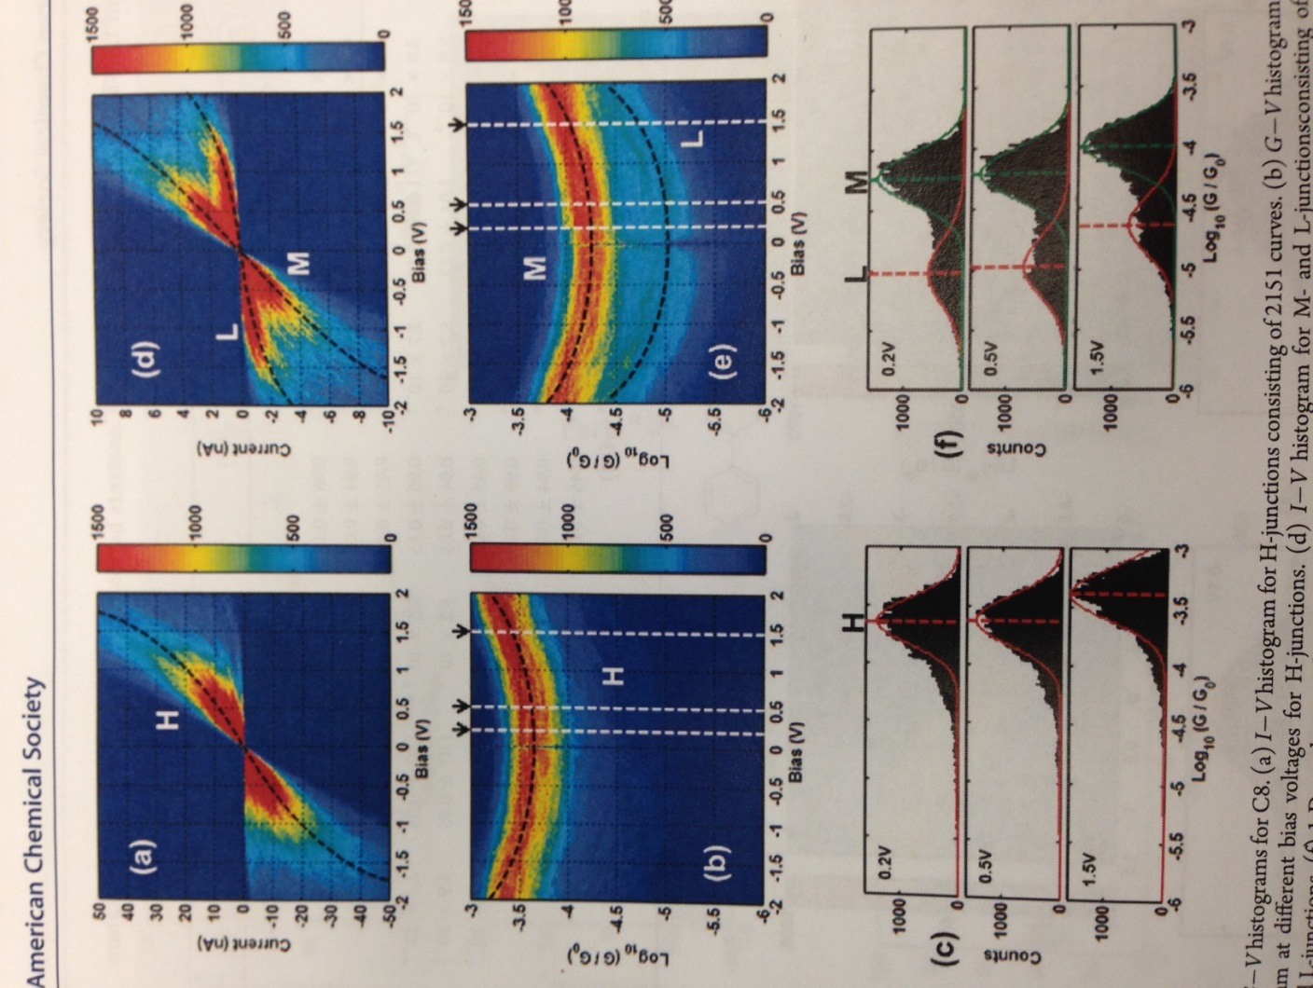

**Figure 3.** Two-dimensional conductance histograms generated from real experimental data for the molecule octanedithiol. (b) shows H-junctions (high conductance values) and (e) shows M- and L-junctions (medium and low conductance values). (c) and (f) are one-dimensional cross-sections [5].

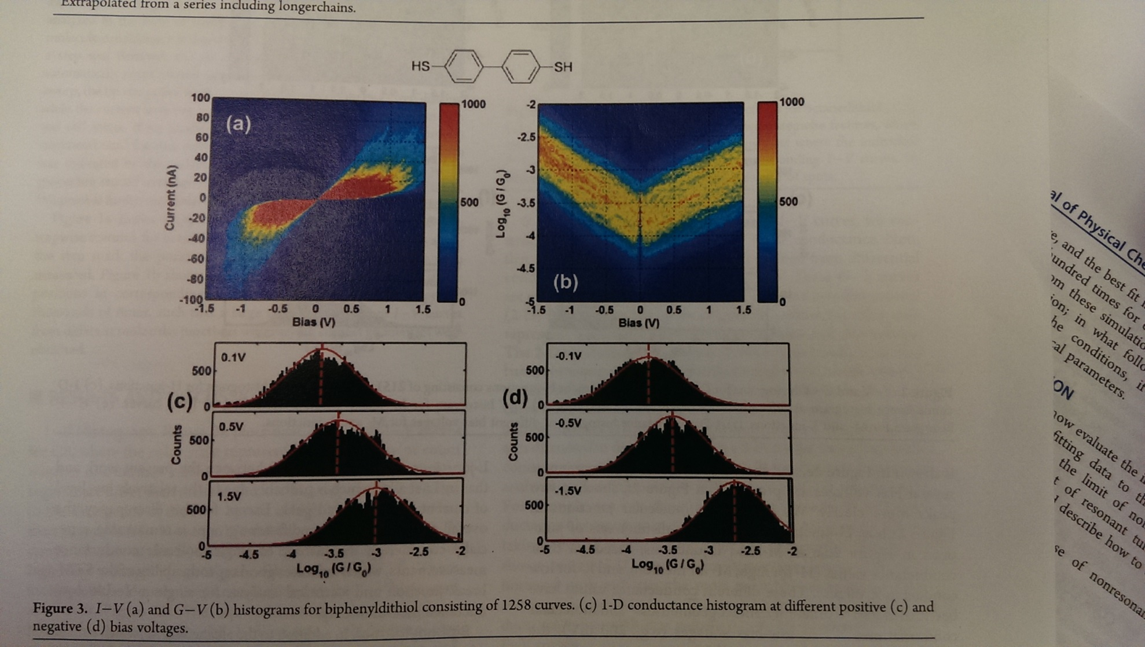

**Figure 4.** (b) is a two-dimensional conductance histogram generated from real experimental data for the molecule biphenyldithiol. (d) contains one-dimensional cross-sections [5].

***i* Model (Voltage-Independent)**

In the *i* (“independent”) model, the transmission function *T* (Equation 2) is left as it is: none of its three variables are affected by the applied bias. The integral thus becomes a voltage-independent constant. The resulting histograms with varied parameters are shown in Figure 5. The figure shows that the relative voltage drop *η* affects the “slant” of the curve dramatically. In contrast, the site level energy *ε* and coupling *Γ* slightly modify the curvature. By comparing the simulated results with the experimental data in Figure 3 of the octanedithiol molecule, the *η* = 0.5 factor in general reproduces the empirical data most accurately. However, none of the curves show the sharp symmetry of the biphenyldithiol molecule in Figure 4.

***s* Model**

In the *s* (“single-site”) model, the *ε* variable is predicted to be linearly dependent on applied bias in the general form *ε* = *ε0* + *eV*. This allows a simplified solution to be found for the integral with the transmission depending on voltage. The resulting histograms are shown in Figure 6. All of the graphs show the same shape, and this model does not seem to correspond to the experimental results of Figure 3b, Figure 3e, or Figure 4b at all.

***d* Model**

In the d (“double-site”) mode, two transmission sites are envisioned within the molecule. The mechanism involves varying two site level energies. In our resulting histograms, shown in Figure 7, it seems that a *ε* value of -3 yields an unexpected phenomenon, causing conductance to drop with the increase of bias. This is taken to be unaccounted-for physics and will not be further analyzed in this project. A *ε* value of -10 yields graphs that utterly do not correspond with the empirical data. The set of histograms of *ε* = -6.5 act similarly to the *ε* = -3 set in the *i* model, while not improving on the fit for Figure 4.

Now do this for figures 6 and 7 too…it doesn’t take long!

b)

c)

a)

**Figure 5.** Two-dimensional conductance histograms for the *i* model, with parameters of *ε* at –a) 3 eV, b) -6.5 eV, and c) -10 eV, while changing *Γ* (0.5, 0.75, 1.0) and *η* (0.3, 0.4, 0.5).

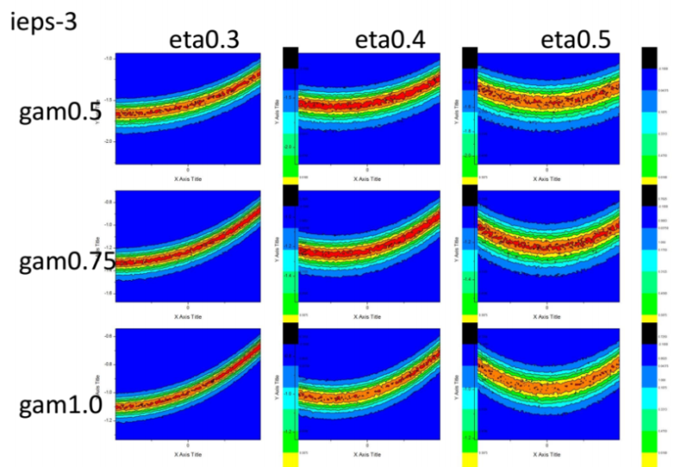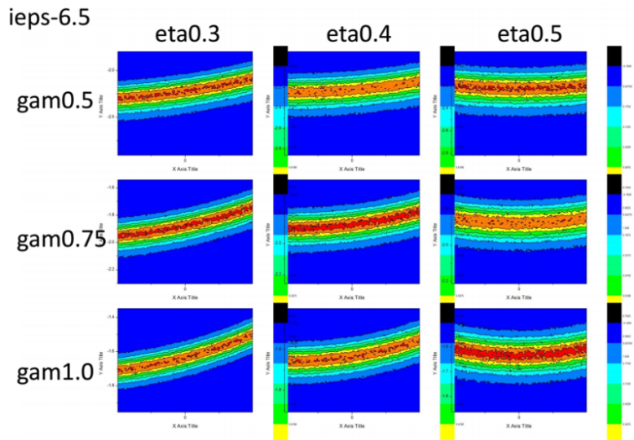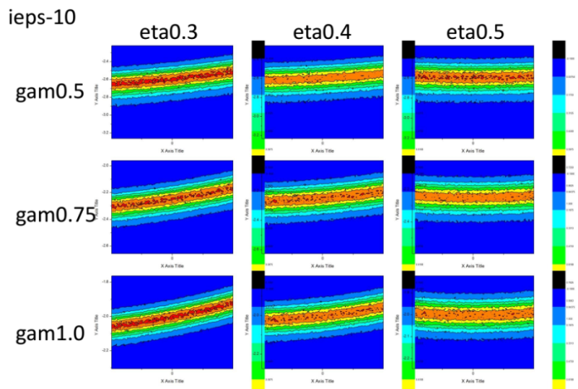

**Figure 6.** Two-dimensional conductance histograms for the *s* model, with parameters of *ε* at -3 eV, -6.5 eV, and -10 eV, while changing *Γ* (0.5, 0.75, 1.0) and *η* (0.3, 0.4, 0.5).

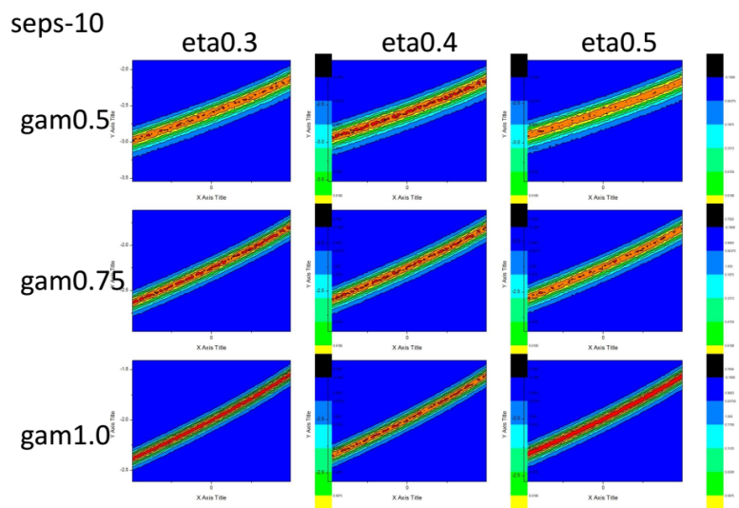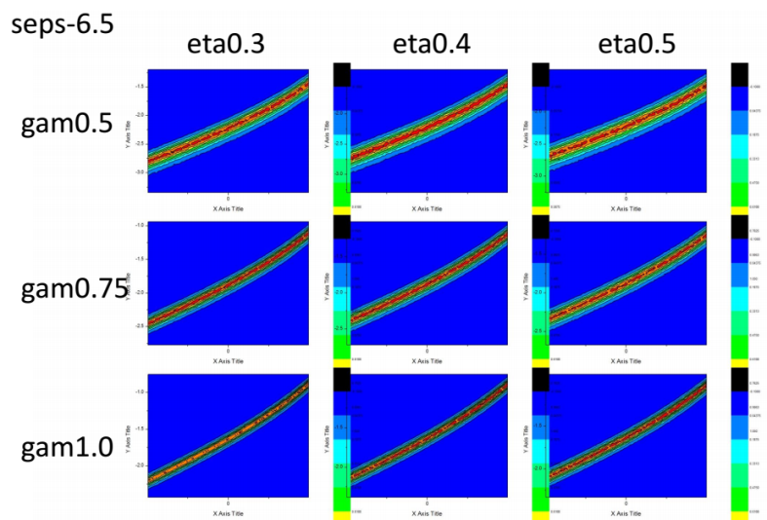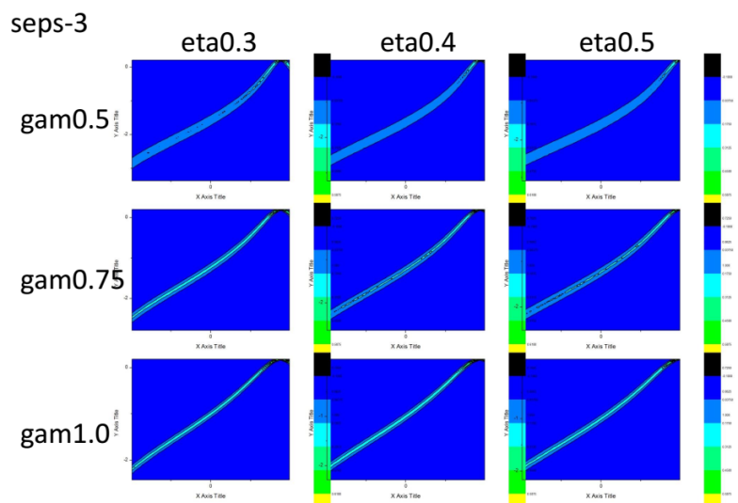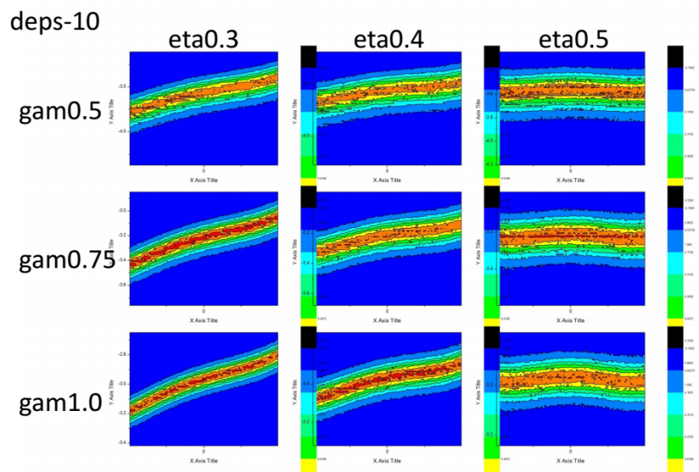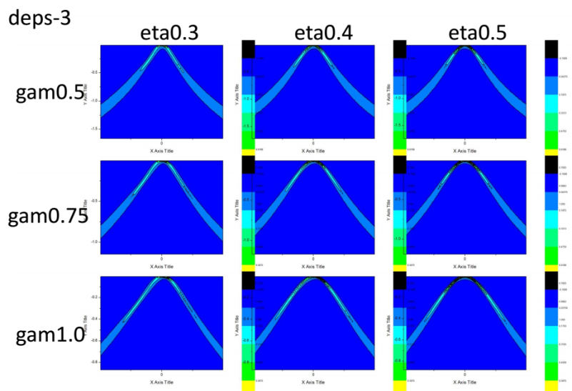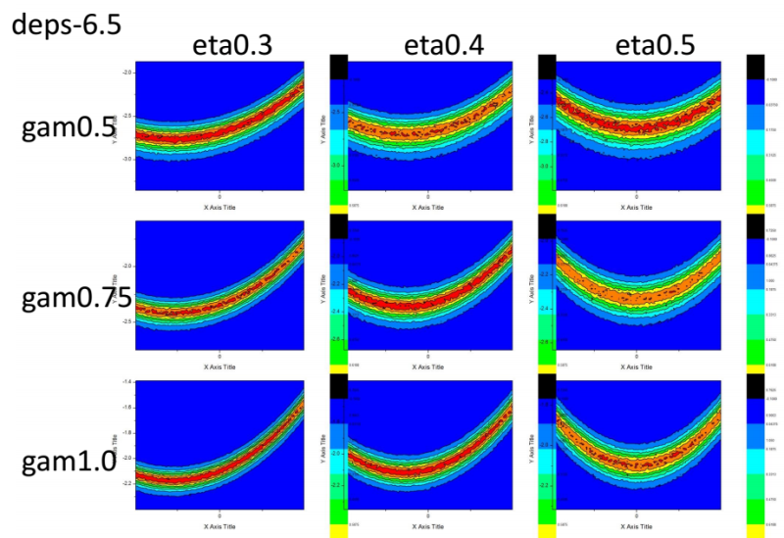

**Figure 7.** Two-dimensional conductance histograms for the *d* model, with parameters of *ε* at -3 eV, -6.5 eV, and -10 eV, while changing *Γ* (0.5, 0.75, 1.0) and *η* (0.3, 0.4, 0.5).

1. **Conclusion**

The goal of this project was to replicate the unique voltage-dependent conductance histograms of S. Guo et al. by generating data with a simulator based on the Landauer-Büttiker-Imry transmission theory. A program based on previously supported variables was created, and it contained three separate models. After generating a plethora of histograms, it is concluded that, while it was possible to recreate H-, M-, and L-junction G-V histograms for octanedithiol, our current models could not match the empirical results for biphenydithiol at all and thus cannot be deemed functional.

1. **Future Work**

Though our current program cannot yield the desired results, it is likely that further investigation into the nature of the unexpected outcomes of our simulator could reveal refinements. For instance, the inverted G-V histogram shape in the *ε* = -3 graphs of the *d* model must be explained.

Future work based on this research should be in search of additional physical factors and models that affect and explain molecular conductance in ways we have not been able to anticipate.

1. **Appendices**

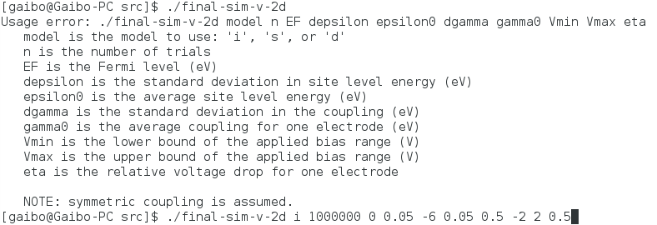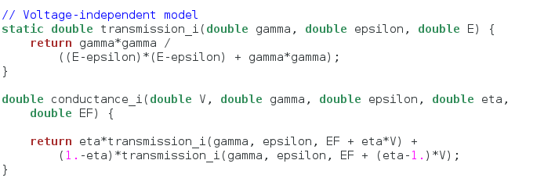

**Appendix 1**: Equation 7 is implemented into the code with these voltage-independent functions.

**Appendix 2**: Using stdin in the terminal, values are fed into the simulator. Here a usage error is purposefully executed to demonstrate the process.

**Appendix 3**: The simulator outputs to the binner, which then outputs to a data file named “outputfile”. Practical and precise naming actually includes the values for the variables.

The output data format is displayed. The first column is bias voltage, the second is conductance, and the third is relative probability.

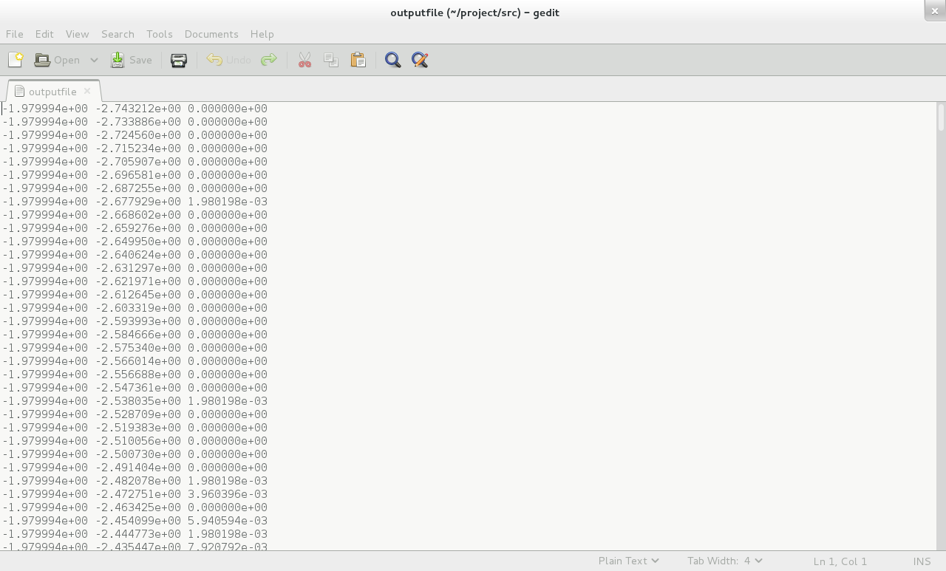

**References**

[1] J. C. Cuevas; E. Sheer. *Molecular Electronics*. World Scientific, 2010.

[2] P. D. Williams and M. G. Reuter, J. Phys. Chem. C **117**, 5937 (2013).

[3] Rolf Landauer; Yoseph Imry. Conductance viewed as transmission. *Reviews of Modern Physics*, 71(2):306-312, 1999.

[4] B. Xu and N. J. Tao, Science **301**, 1221 (2003).

[5] S. Guo, J. Hihath, I. Díez-Pérez, and N. Tao, J. Am. Chem. Soc. **133**, 19189 (2011).

[6] M. G. Reuter, M. C. Hersam, T. Seideman, and M. A. Ratner, Nano Lett. **12**, 2243 (2012).